**Giaus Gracchus**

**Biographical Facts and Information About Me**

**(Keep it Short and Sweet – KEY Information in Bullets)**

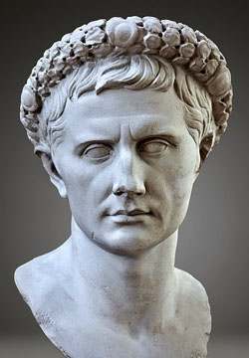

**Explain Why or Why Not:**

**For Expansion**

**Or**

**Against Expansion**

**Main Points on Roman Expansion**

**(Keep it Short and Sweet – KEY Information in Bullets)**