New Kingdom Pharaohs
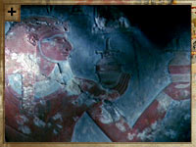
Hatshepsut depicted in a frieze
The New Kingdom saw the reign of some of Ancient Egypt's most powerful and charismatic pharaohs.
The word pharaoh comes from the Egyptian 'per-aa', meaning 'great house' and referred to the royal palace. Only quite late in the New Kingdom did it come to refer to the king himself.
Like other kings, the pharaoh sat at the top of the social and political order, acted as commander-in-chief and controlled all military occupations. But the pharaoh was much more than just the head of state. He also helped maintain 'Maat' - the divine order in the world. Without the pharaoh, The Egyptians believed that the world would descend into chaos.
The pharaohs of the New Kingdom show how individual strengths and weaknesses could affect the fortunes of the Egyptian empire. Ahmosesuccessfully expelled the Hyksos from Northern Egypt and defeated the Nubians to the south, while Hatshepsut used her cunning to overcome her gender, tame her army and boost her own reputation.
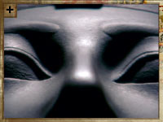
Click on the image for a gallery view
Tuthmosis III was forced to wait for 20 years before becoming king, but wasted no time: his victory at Megiddo saw Thebes become one of the richest and most powerful cities in the ancient world. Amenhotep III avoided the need for war altogether through a clever combination of diplomacy, marriage and gold. But his son, Akenhaten, nearly threw it all away by his religious obsession and persecution of other gods.
This would not last. His son, Tutankhamen, abandoned Egypt's new capital, Amarna, and overturned his father's heresy, before dying mysteriously at the age of just 19. Finally, the propaganda, diplomacy and monumental building programs of Ramesses II made him the ultimate pharaoh. His death, however, would mark the beginning of the end for the Egyptian empire.

http://www.pbs.org/empires/egypt/newkingdom/pharaohs.html

