New Kingdom and Egyptian Society
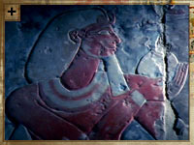
Tuthmosis represented in a frieze
Ancient Egypt was an ordered society with a distinct hierarchy. Yet things were beginning to change.
The demands of an expanding empire offered opportunities for the educated and the skilled to be upwardly mobile.
The social order
The class structure in Egypt was extremely rigid: everyone knew where they stood in society and most accepted their position. At the top of the tree was the pharaoh, an almost god-like figure who stayed aloof from his people. Underneath him were Egypt's social elite, the nobles, who effectively governed Egypt for the pharaoh.
Lower down were the educated professional classes, such as scribes, accountants and doctors. Beneath them were the workers and craftsmen, like soldiers and builders. At the very bottom were the slaves and servants, as well as farmers who worked on land owned by the pharaoh and the social elite.
Reading and writing
Before the New Kingdom era, your status was dictated by that of your father and ancestors. Movement between social classes was almost impossible.
But as the empire grew, Egypt needed more educated men to run it properly. There was a massive increase in the professional, educated classes and this enabled bright young Egyptians to move up the social ladder.
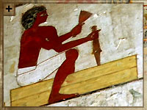
Click on the image for a gallery view
Opportunities for all?
The empire provided new opportunities for many. The need to conquer and then control new countries put new responsibilities onto the army. Professional soldiers became more respected and better paid.
The vast amounts of money pouring into Egypt also led to a huge increase in the number of temples, which gave priests much more power. This money was also used to build magnificent new tombs and temples: an entire village - Deir el-Medineh - was constructed to house the skilled workers who would build these tombs.
The more things changed...
Although the empire did bring some social change, much stayed the same. Peasants and servants remained at the bottom of the heap. And althoughwomen were highly respected and enjoyed many legal rights, they were still largely confined to the home, tending to children and housework. Egypt was changing, but it wasn't changing that much.

http://www.pbs.org/empires/egypt/newkingdom/society.html

