World History I
Mrs. Bailey

Minoan or Mycenaean? – Assessment
You have had the opportunity to learn about and explore the civilizations of the Minoans and the Mycenaeans. From the information you have learned, to which civilization would you have rather belonged?

State a Claim: I would rather have belonged to the ______________ civilization.
Support with Evidence: Support your position with at least THREE pieces of evidence from class materials, notes, or other sources. Remember to use quotations when directly citing evidence! Your essay response should be at least one well-developed paragraph and no more than a page in length.

Rubric
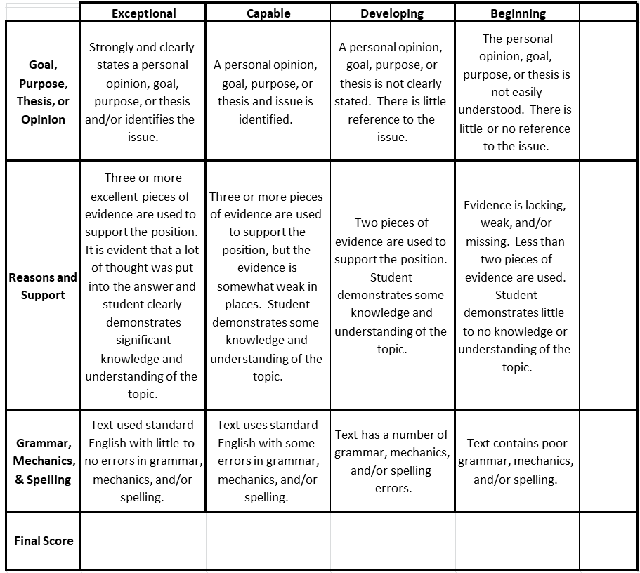

Competency: SS Communication (SSC4) | 4 | 3 | 2 | 1
I can state a claim and back it up with accurate and appropriate evidence. | No errors and student had thoughtfully constructed questions/answers that seek to gain a deeper understanding of the topic. | Assignment was completed as required. | Assignment was completed but lacks correct information. | Assignment is incomplete.

