World History I
Mrs. Bailey
Chapter 4: The Ancient Greeks
Section 4: The Age of Pericles

- Define:
  - direct democracy

  - representative democracy

- Explain how direct democracy and representative democracy are different.

Using this chart, found on page 140 of our textbook, complete questions 3 and 4:
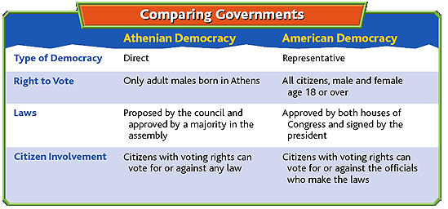

- In Athens, how was a law approved?

- Compare and determine which government granted the right to vote to more of its population?

Using the map on page 144 of your textbook answer questions 5 and 6 about the Peloponnesian War (431-404 B.C.):
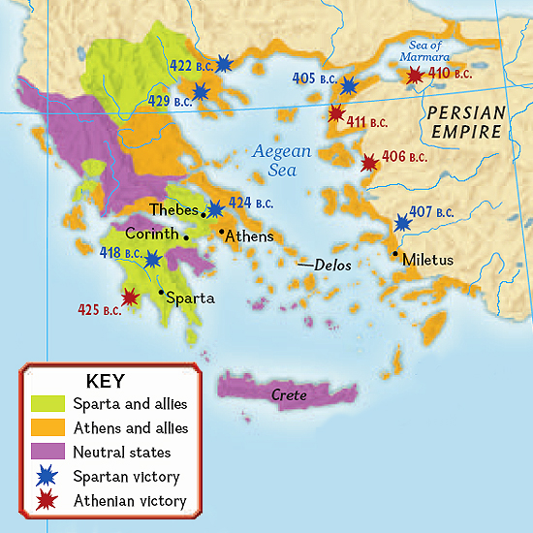
- In what year was the earliest battle of the war fought and in whose territory was it fought?

- Which major cities were allied with Sparta? How do you think having those allies helped the Spartans to win the war?

Read the primary source below (Pericles’ Funeral Oration from page 145 of our textbook), and then answer question 7:
Pericles was a dominant figure in Athenian politics between 461 B.C. and 429 B.C., a period historians call the Age of Pericles. In his Funeral Oration, given during the Peloponnesian War, Pericles described democracy, the importance of the individual, and citizenship.

”Our constitution is called a democracy because power is in the hands not of a minority but of the whole people. When it is a question of settling private disputes, everyone is equal before the law; when it is a question of putting one person before another in positions of public responsibility, what counts is not membership of a particular class, but the actual ability which the man possesses. No one…is kept [out of government] because of poverty. And, just as our political life is free and open, so is our day-to-day life in our relations with each other.”
--Pericles, as recorded by Thucydides,
History of the Peloponnesian War

- When Pericles said “everyone is equal before the law,” what did he mean? In your opinion, is everyone equal before the law in America today? Explain.

- What effects did the Peloponnesian War have on Greece?

