World History I
Mrs. Bailey
Chapter 4: The Ancient Greeks
Section 3: Persia Attacks the Greeks
- As you read this section, complete the following graphic organizer:

Ruler | Accomplishments
Cyrus
Darius
Xerxes

Using the map on page 132 of your textbook, answer questions 2 and 3:
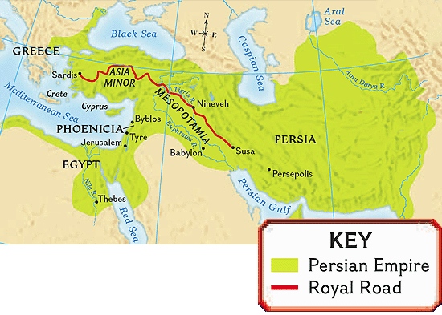
- About how long was the Royal Road?

- Based on the map, why might the Persian Empire have been a threat to Greece?

Read the primary source below (Herodotus’s History from page 135 of our textbook), and then answer question 4:

The Greek historian Herodotus wrote History of the Persian Wars., which is thought to be the first real history in Western civilization. Herodotus described the conflict between the Greeks and Persians as one between freedom and dictatorship. Here he tells of Xerxes’ address to Persian nobles:

“And truly I have pondered upon this, until at last I have found out a way whereby we may at once win glory, and likewise get possession of a land which is as large and as rich as our own…while at the same time we obtain satisfaction and revenge…My intent is to …march an army through Europe against Greece, that thereby I may obtain vengeance from the Athenians for the wrongs committed by them against the Persians and against my father.”
--Herodotus,
The Persian Wars, Book VII

- What reasons besides revenge does Xerxes have for invading Greece?

- List the causes which led to the Persian Wars.

Persian Wars

