Buddhism vs. Hinduism Station Activity
Name___________________________________________________________________Date______________Period_____Points______/20
Instructions: Write down ideas between Buddhism and Hinduism and similarities using the Venn diagrams below and using the different stations to understand Buddhism and Hinduism. Each Station will have one Venn diagram.

Station 1: Gods and Goddess
Buddhism
Hinduism

Station 2: Goal of Religion
Buddhism
Hinduism

Station 3: Birth Religion

Buddhism
Hinduism

Station 4: Fun Facts
Buddhism
Hinduism
Hinduism Gods:
Station One: Gods and Goddesses
Much like Egyptian culture, Hindus believe in many gods. However, Hindus believe that all the gods come from Atman, meaning no one supreme being. Atman means “inner-soul” and is connected to the universe. Hindu gods and goddesses are famous across the world and important to the stories in Hinduism. One god, Vishnu, is extremely famous for having many arms, but he is one of most important gods, as he is “The Protector” and part of the three supreme gods. Shiva is another important god, and another of the supreme deities. Shiva is destroyer of the worlds and many people consider Shiva to represent the most essential goodness. The last of the three supreme deities is Brahma, the creator of life. He is famous for also having four faces. There are many other gods and goddesses in Hinduism and each serve a purpose to help guide people until the next life.

Vishnu Brahma
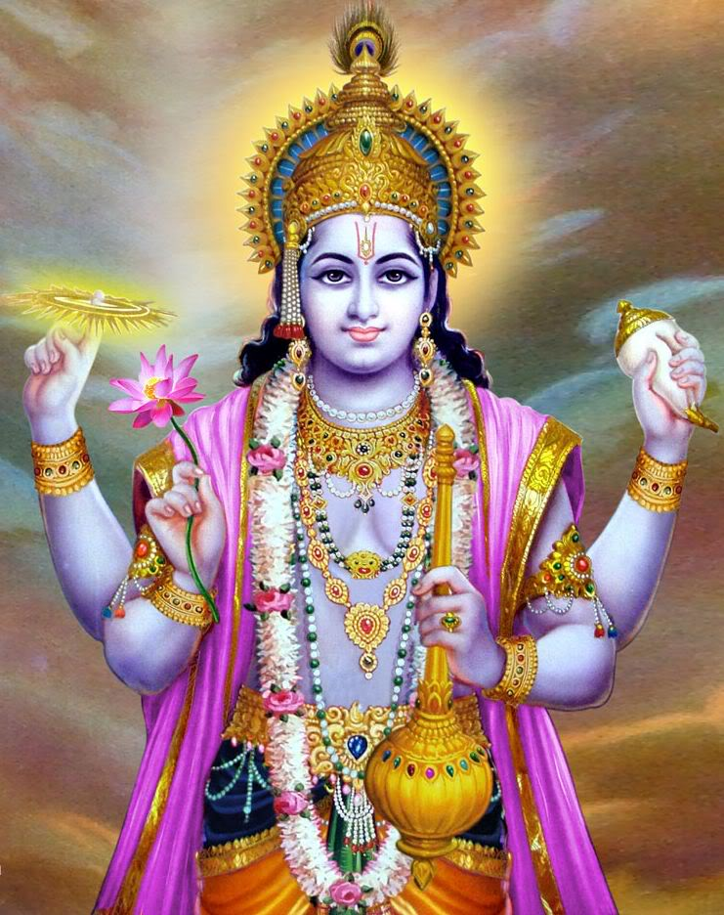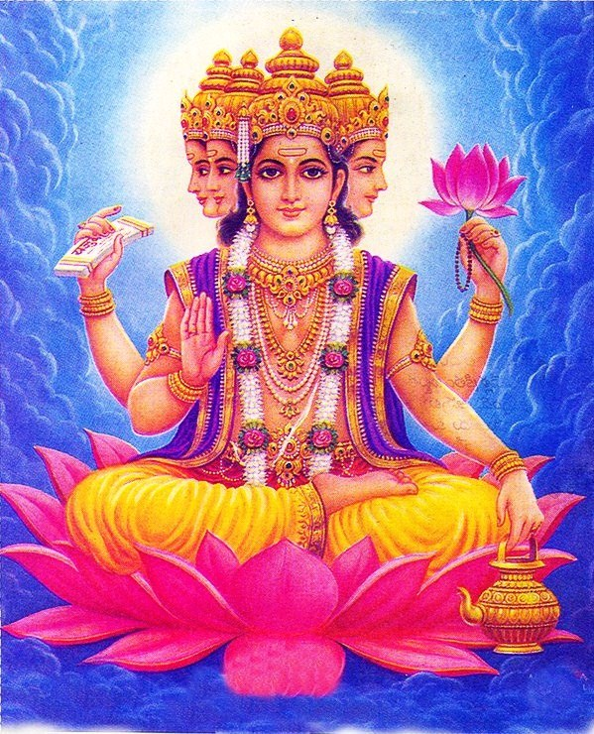

Buddhism Gods:

Buddhists, though had roots in Hinduism, do not actually believe in any gods. There are many reasons why Buddhists do not believe in gods, but their goal is not to please god, but to escape suffering. Buddhists believe that the only person who can stop suffering is the person who is suffering to seek a way to ease their own suffering. Buddhists however do not mind if someone believes in a god, as long as it helps to reduce their suffering. A common myth about Buddhism is that Buddha was a god, but Buddha was not a god, he was a teacher. Though Buddhists worship him, they recognize that he was a man who obtained enlightenment first.
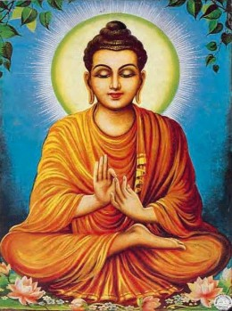

The goals of both religions are to, in simple terms, die and stay dead. Reincarnation, or rebirth, is important to both religions and depending on how people live their lives or follow their guidelines, they can be reborn in a higher setting, such as heaven or be reborn an animal or even into infernos. While both religions seek escape from the cycle of rebirth, they do so in different ways.
Station Two: Goals of the Religions
Hindus believe in karma. The actions you do in this life will affect where you end up in the next life. The better life that you lead and the more positive karma you obtain the better chance you have at obtaining moksha, which is the escape from reincarnation. Karma is also determined by how well you perform your required tasks. Brahmin’s, the highest caste tier, are expected to lead others in understanding Hinduism. Kshatriyas are the warriors, Vaisyas are merchants and farmers, and Shudras are the maintenance people. An important idea with Hinduism is also spiritual emancipation and reuniting with God. By gaining positive karma and seeking spiritual emancipation, becoming one with God and escaping reincarnation is possible.
Buddhists believe in the Four Noble Truths and by following these will you allow you to break away from life and become one with the universe. The first of the Noble Truths is the truth of Dukkha, or suffering. The second Noble Truth is the origin of Dukkha, or how suffering is created. The third Noble Truth is the end of Dukkha, or the end of suffering. The fourth Noble Truth is how to attain the end of suffering through the Eightfold Path. The Eightfold Path is Right Understanding, Right Thought, Right Speech, Right Action, Right Livelihood, Right Effort, Right Mindfulness and Right Concentration. By accepting the truths and following the Eightfold Path, anyone can obtain Nirvana, or the blowing out the flames of suffering and become one with the universe.
All religions have a start that is extremely fascinating and helps to explain why a religion may grow. Hinduism is considered to be the oldest religion in the world, and as such, some people call it the “eternal law.” Hinduism is unique in that there is no definite beginning with it. Instead, Hinduism is believed to be a fusion of various India culture and traditions, extending back nearly 4,000 years ago. As such, Hinduism has no one holy book, like Christianity or Islam. However, Hinduism has many books, with no one book being the one for all Hindus. However many agree on certain books and one of the most important books and famous books is the Bhagavad-Gita, which goes into details about why it’s important to follow your caste job and perform it well. While the Bhagavad-Gita is only one of the many books, Hindus will read many texts to help them on their path towards reaching their ultimate goal.
Station Three: Birth of the Religions
Buddhism’s start is well documented and followed. The person known as Buddha now was known as Siddhartha and he was a prince. He lived his entire life in the palace, never seeing any of the outside world. One day, after being bored with his life decided to travel. On his travels he met an old man, a diseased man, a decaying corpse, and an Ascetic, or someone who gives up worldly pleasures in pursuit of spiritual goals. After this trip he became a beggar, living on other’s kindness and learning yoga from masters. Feeling as though they did not provide answers, Siddhartha goes further and starts being an extreme ascetic, giving up food. Nearly drowning, he was saved by a little girl. After this point, Siddhartha realizes that he wasn’t finding the answers he was seeking. Legend states he stayed underneath a papil tree until he uncovered the truth. After 49 days of meditation, he found Enlightenment and discovered the Four Noble Truths. He spent the rest of his life teaching about what he learned about with escaping suffering of life.

Hinduism
Station Four: Fun Facts

- Hinduism is the third largest religion, with almost 750 million people, but 95% of Hindus live in one country, India!

- The board game Snakes and Ladders was originally created to teach Hinduism to children.

- Unlike Western culture understanding of time, Hindus believe in a circular time line.

- A Hindu can be atheist, belief in no god, monotheist, belief in one god, and polytheist, belief in many gods, all at the same time!

- Speaking of gods, Hinduism has nearly 330 million gods and goddesses!

- Rig Veda, one of Hinduism’s fundamental books, was orally passed down for 3,500 years, yet amazingly it has no major discrepancies, meaning it is extremely similar among all the stories.

- 108 is the holiest number. This is the ratio of the distance from the earth to the Sun and the Sun’s diameter.

- In Hinduism, the cow is thought of as a source of food and a symbol of life … cows cannot be killed. In Hinduism, they do not worship cows however, but they do revere them.

Buddhism

- Buddha was not chubby. He is shown as being chubby as this represents happiness in the east.

- Buddha’s spot of Enlightenment underneath the Bodhi Tree is still there today.

- The Dalai Lama is only the head to Tibetans Buddhist and is the head of the Tibet government. He is the incarnation of the compassion of all Buddhas.

- There are two types of Buddhists, Mahayana, who believe anyone at any time can obtain Enlightenment and Theravada, who believe Enlightenment comes from several lifetimes.

- When Siddhartha was born, sages told his father he would grow up to become a great king or a great sage.

- If you asked a Buddhist and/or a Hindu what is the point of their religion, they would both say that it is not a religion but a way of life and that way of life will continue for eternity.

